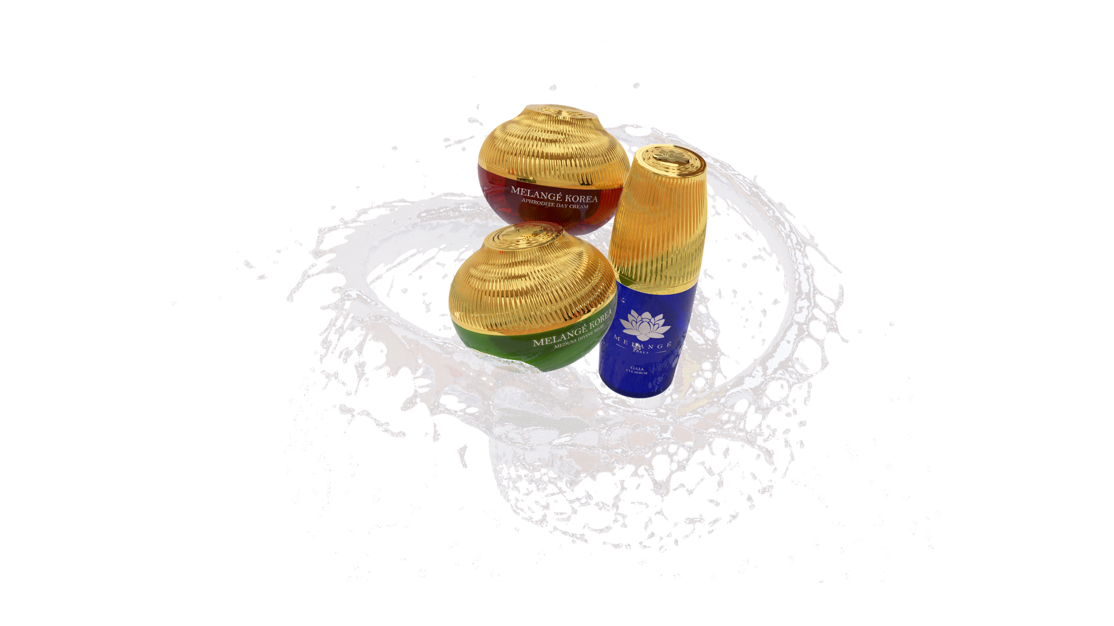

“Korea’s Best Kept Secret”
MELANGÉ KOREA Introduces
Premium Skincare Line
Rooted in Korean Tradition and Innovation
MELANGÉ KOREA is proud to unveil its newest line of premium skincare products, a harmonious fusion of Korean beauty traditions and modern innovation. Known for its uncompromising dedication to quality, MELANGÉ KOREA brings the essence of Korean skincare directly to your daily regimen, ensuring a unique and elevated experience.

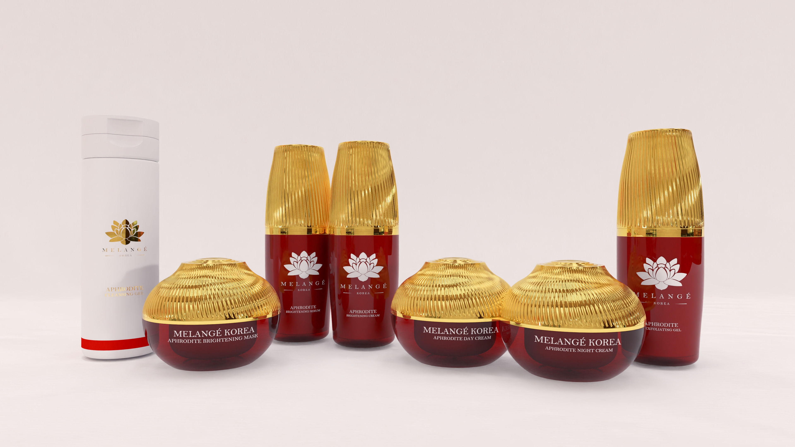

The Aphrodite Collection
For All Skin Types
Indulge in the luxurious, nourishing Aphrodite collection, crafted to promote healthy, radiant skin. This line features a rich blend of hydrating ingredients, offering an effective solution for maintaining skin's natural beauty.
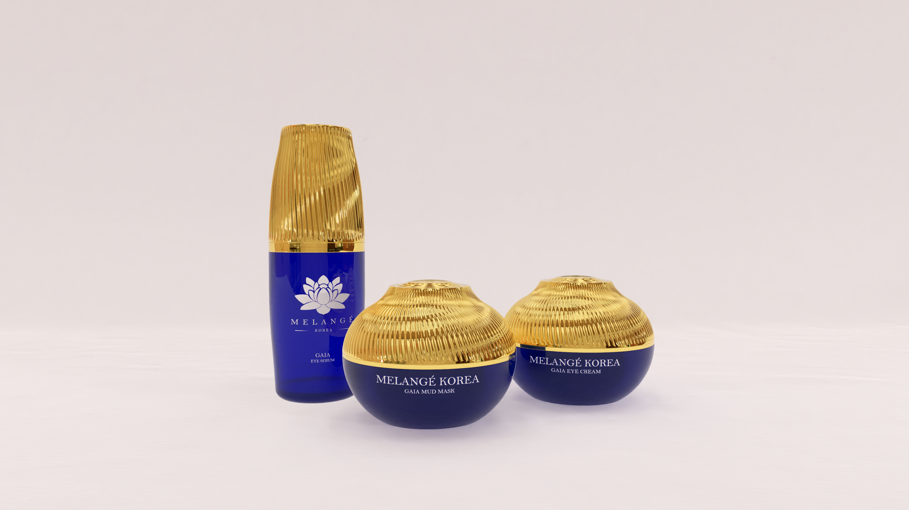

The Gaia Collection
Natural and Efficient
The Gaia collection embraces earth-based ingredients, offering a gentle yet powerful solution for those who prioritize natural, eco-conscious skincare. Gaia products rejuvenate and nourish the skin while promoting overall well-being.
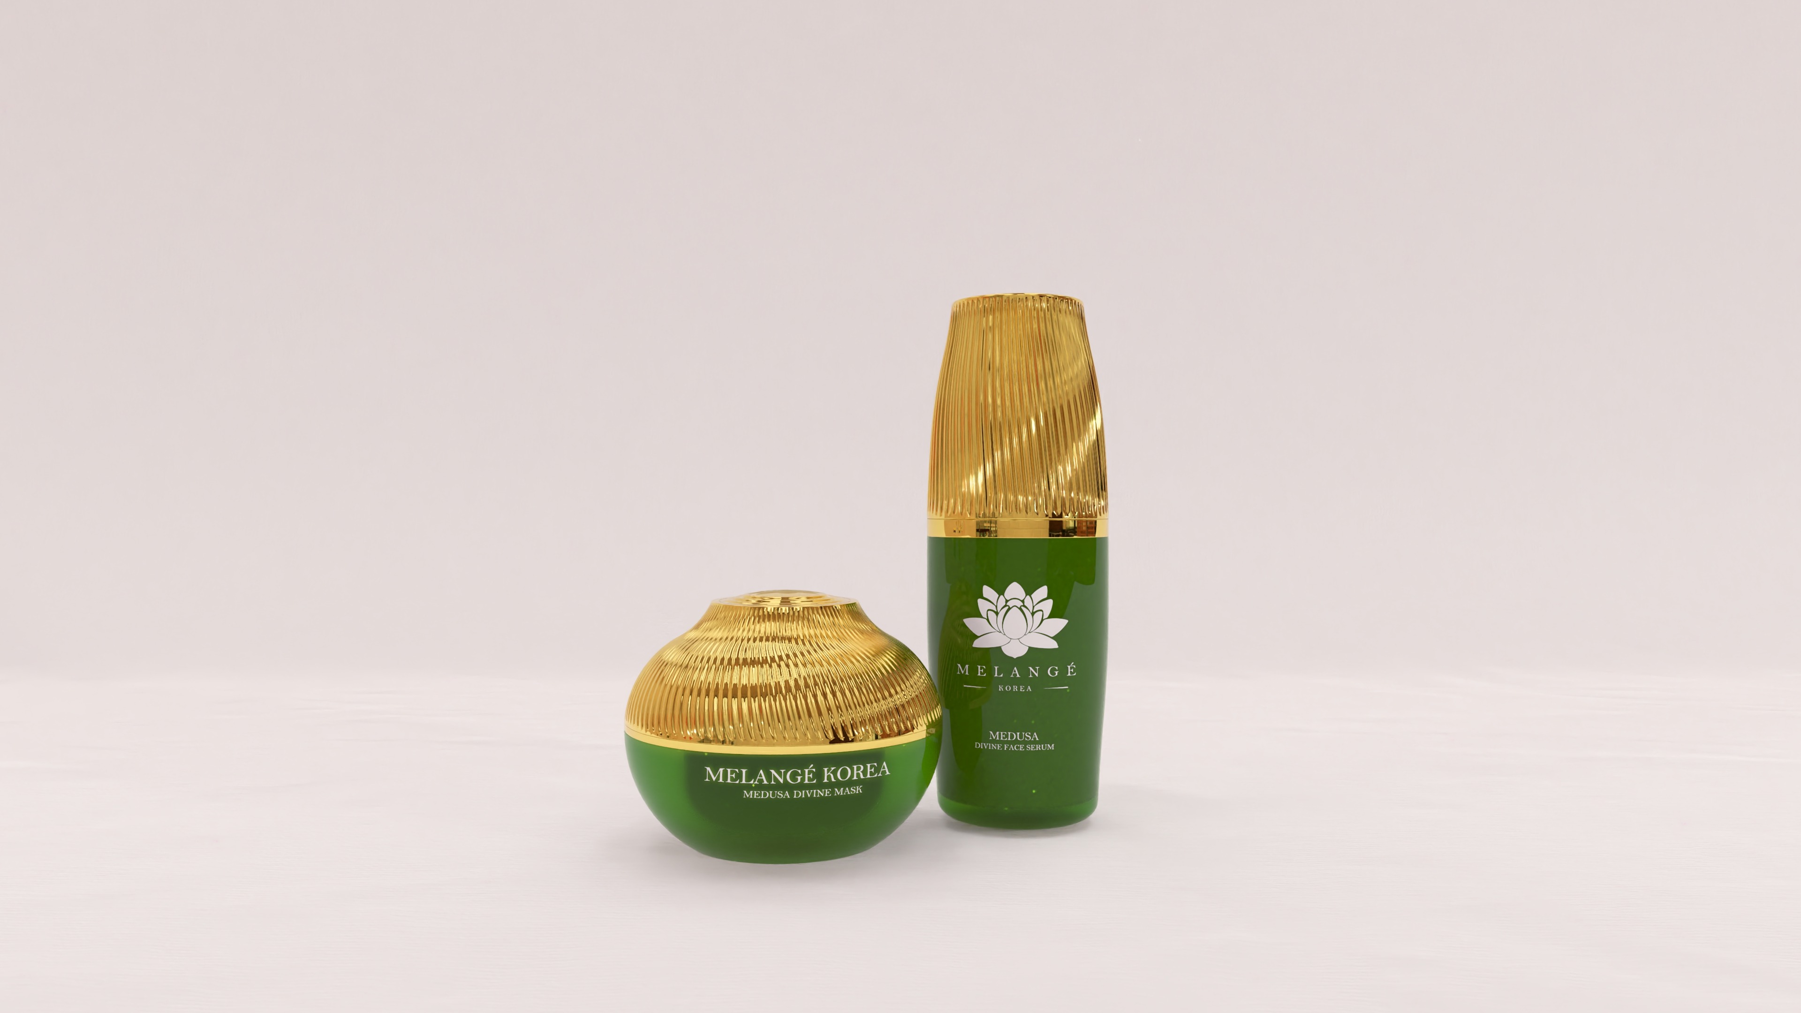

The Medusa Collection
Anti-Aging Mastery
Combat the signs of aging with the Medusa collection, expertly formulated with a blend of natural ingredients and advanced technologies. These products help restore collagen and improve skin elasticity, leaving your skin refreshed and youthful.
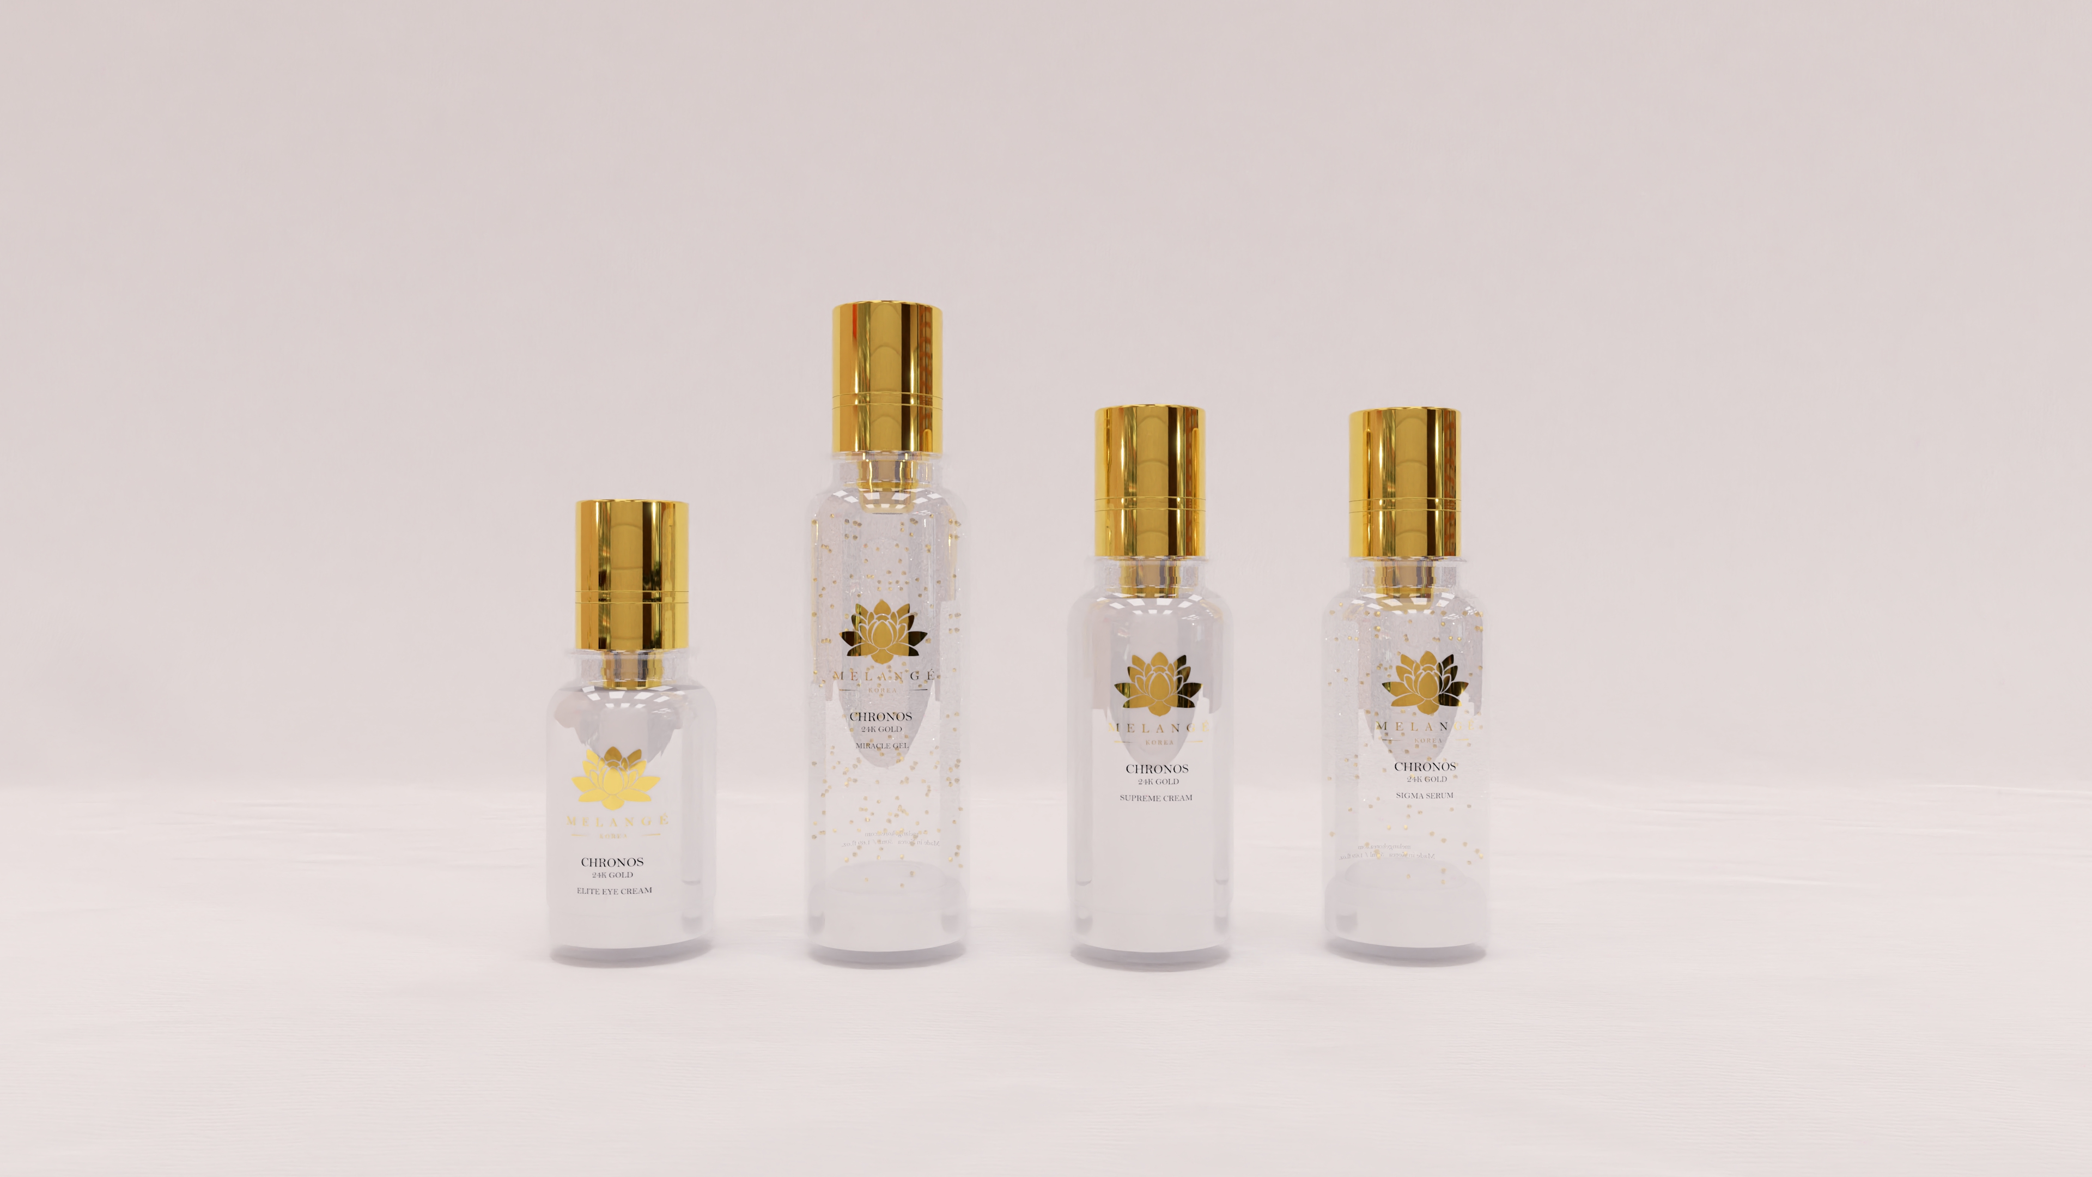

The Chronos Collection
Where High-End Luxury Meets Skincare
For the ultimate indulgence, experience the Chronos collection. Enriched with 24K gold, this range redefines luxury in skincare, offering unparalleled rejuvenation and radiance. Chronos is the epitome of beauty and elegance, tailored for those who seek the extraordinary.
Why MELANGÉ KOREA Stands Out
Innovation and Rigorous Testing Standards
MELANGÉ KOREA leads the charge in the world of skincare by merging ancient wisdom with cutting-edge technology. Our products are meticulously crafted by a team of expert scientists and skincare specialists, who rigorously test every formulation to guarantee maximum efficacy. Every product undergoes comprehensive and thorough testing to ensure it is both safe and effective, all while upholding ethical and environmental standards.
Harnessing the Power of Nature
MELANGÉ KOREA’s philosophy is deeply rooted in nature. We source the finest natural ingredients—including green tea, ginseng, kelp, and a variety of fruits and flower extracts—to provide your skin with nourishment, hydration, and vitality. Each product is a celebration of nature’s gifts, designed to pamper and rejuvenate.
Personalized Skincare Solutions
Understanding that every person’s skin is unique, MELANGÉ KOREA offers a diverse range of products tailored to meet specific skincare concerns. Whether soothing sensitive skin or addressing the signs of aging, our customizable products allow you to curate the perfect skincare routine for your needs.
The Ritual of Self-Care
MELANGÉ KOREA transforms skincare into an artful self-care ritual. With a thoughtfully curated collection of cleansers, masks, toners, essences, and more, you can elevate your skincare routine into a meaningful journey that reveals your skin's natural beauty.
Commitment to Ethical Beauty
Melange Korea proudly adheres to the highest ethical standards:
- Paraben-Free
- Cruelty-Free (No Animal Testing)
- Naturally Derived Ingredients
- Made in Korea
MELANGÉ KOREA invites you to discover the unparalleled excellence of Korean skincare. Each product is meticulously crafted to meet your skin’s needs, combining the best of nature and science for truly transformative results.
For more information, visit melangekorea.com or contact us at:
Phone: 1800220220 (Toll-Free) Phone: (021) 51012325 (Indonesia)
Email: melangemalaysia@gmail.com Email: cs@melangekorea.id
Website: melangekorea.com Website: melangekorea.id
Facebook: melangekorea (Malaysia), melangekoreashop (Indonesia)
Instagram: melange_korea (Malaysia), melange.idn (Indonesia)

